User Manual

5e Character Forge Application

Table of Contents

1. Overview3
2. Getting Started3
3. Character Creation4
4. Character Maintenance4
5. Maintaining Settings6
6. Additional Items / Frequently Asked Questions7

# Overview

In Dungeons and Dragons, or D and D for short, players use character sheets to track their important information regarding their in game character (such as name, level, stats, and skills). Unfortunately, these character sheets are primarily in print, and those few online compatible character sheets are subpar at best. This makes it more tedious and time-consuming, since players are required to monitor their characters in a manual style, as they need to perform actions such as leveling up, monitoring currency, and rolling dice. In order to combat this problem, the 5e Character Forge application was created. This application places emphasis on being able to monitor created characters in an efficient manner. In addition, 5e Character Forge allows for the storing and managing of multiple characters, making it easier to keep track of characters if one is playing multiple games without having to keep track of physical pieces of paper. This application is supplemental to the D and D 5th edition player’s handbook, created by Wizards of the Coast. As such, the application serves to replace only the character sheet used to track character progression, not the book itself. The following documentation describes how to use the application, which includes, but is not limited to, launching the application, creating characters, and frequently asked questions.

# Getting Started

1. Launch Screen

When beginning the 5e Character Forge application, the user is brought to a splash screen:



The user can continue by pressing any key, which will redirect him or her to the start menu of the application.

1. Start Menu

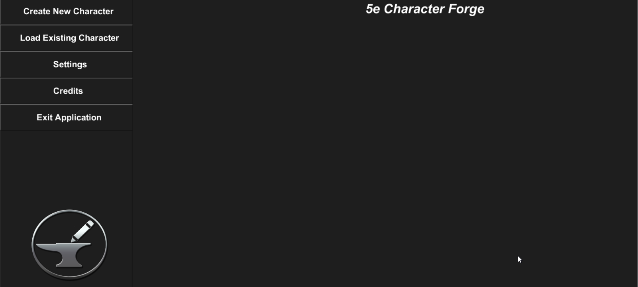

While in the start menu, the user has the following options:

* Create New Character – begin the creation process for a new character
* Load Existing Character – load all saved existing characters so the user may select which one to load
* Settings – screen in which the user can maintain universal settings, such as background music volume and whether the application mode is online or offline
* Credits – acknowledgements in regard to who worked on the application and crediting others for the use of their resources
* Exit Application – enables user to end the application

1. Credits

In order to view the credits of the application, the user can select the credits button in the start menu (see below).

While viewing the credits, the user can opt to go back to the start screen or wait until the credits finish rolling to be automatically returned to the start screen.

# Character Creation

The

# Character Maintenance

The

# Maintaining Settings

# Additional Items / Frequently Asked Questions